**Angular 11 Tutorial – Video Game Info Page**

<https://www.youtube.com/watch?v=LiOzTQAz13Q>

# Setup

* Create a new angular project
* 
  + HAVE TO INCLUDE app routing from here
  + ng new ng-video-game-db --style=scss --routing=true
  + 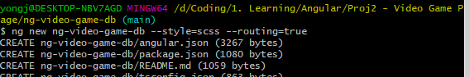
* Add @angular/material
* 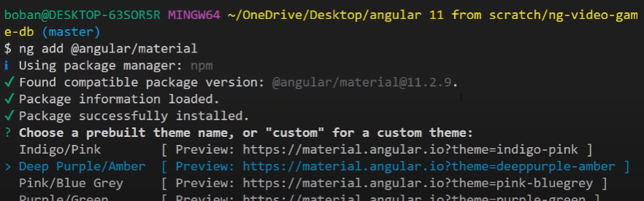
  + I had to include –skip-confirmation at the end
  + 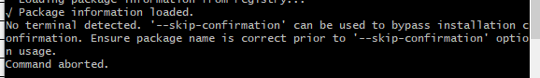
* 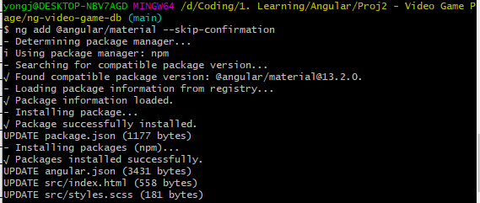
* Including angular-gauge plugin
* 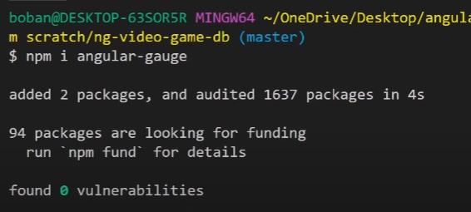
* Import modules into app.module.ts
* 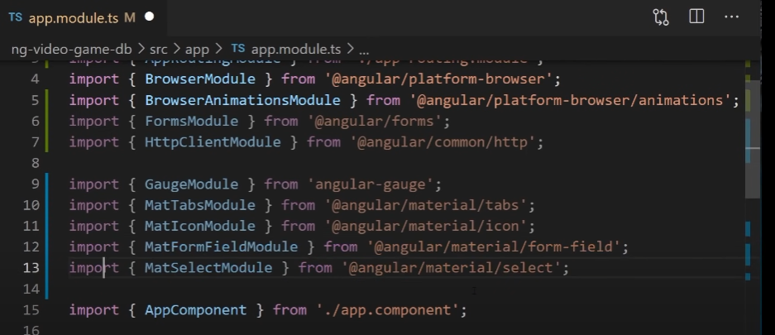
* Adding AppRoutingModule
  + This is an alternate method if the app routing was not setup during “ng new” see very top
  + 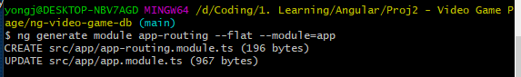
  + 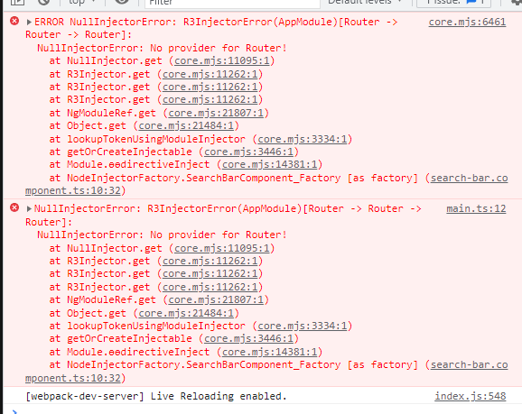
    - NullInjectorError: R3InjectorError(AppModule)[Router -> Router -> Router];
    - NullInjectorError: No provider for Router
  + <https://angular.io/tutorial/toh-pt5>
  + The route seems to work when you define a path in the routes and setup the routes and routermodule as seen below
  + 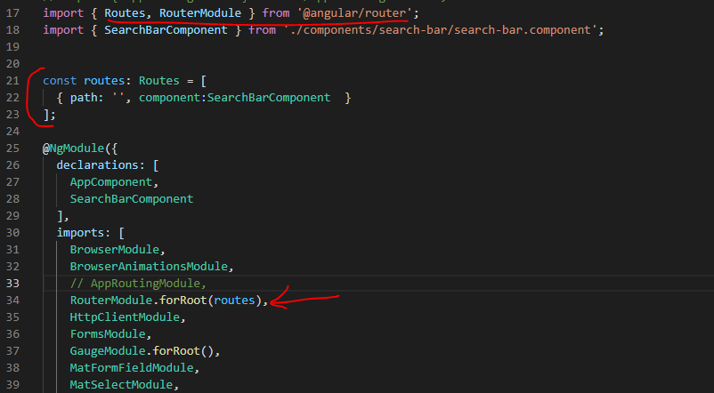
  + 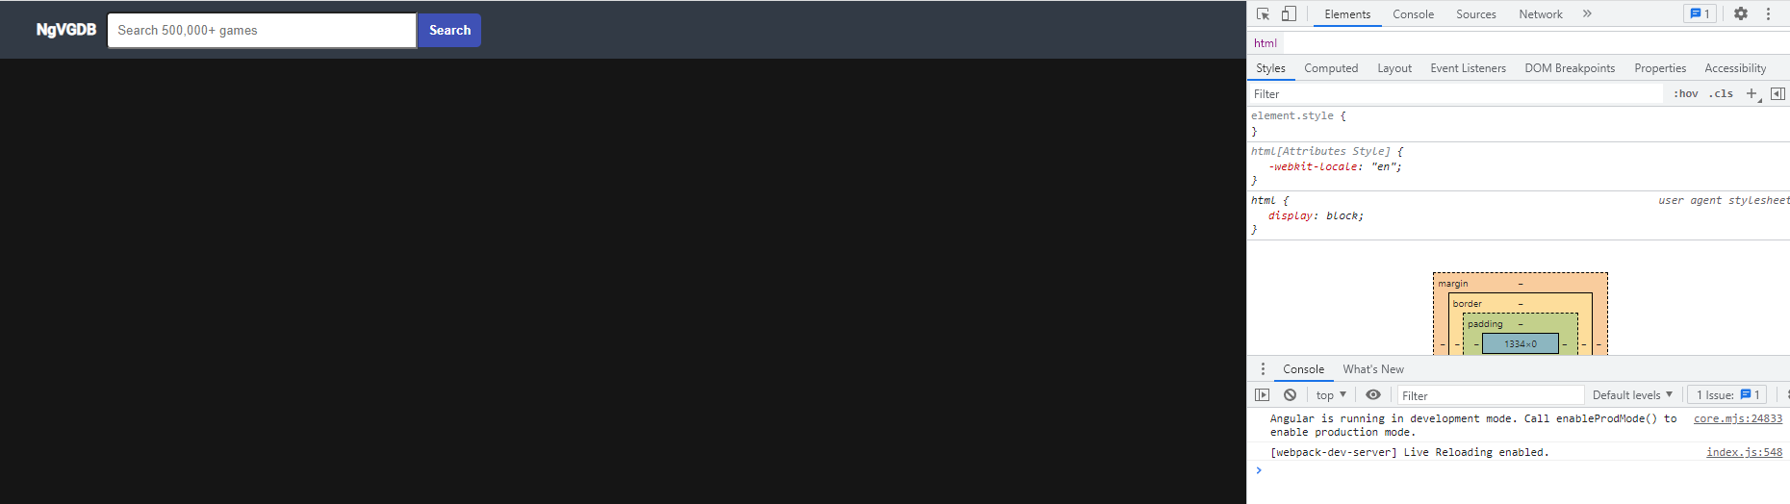
* Include all the modules to be imported
* 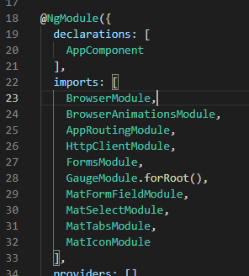
* Go into src/app directory and make new directory
* 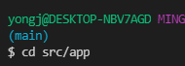
* 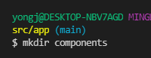 cd into components dir

# Search Bar Component

* Ng generate component search-bar
* 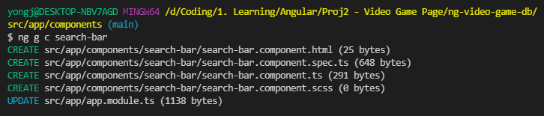
* Add the selector for the component from component.ts file into the app.component.html where we will replace the boilerplate code
* 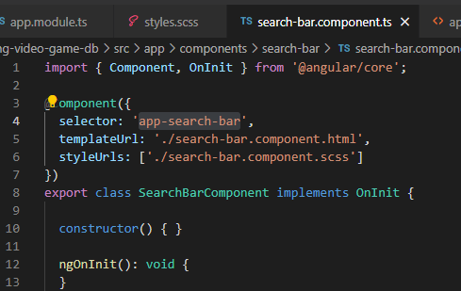

## Surround text with html tag & SCSS

* Paste in the selector, enter in a “>” and the component should become available, hit enter
* 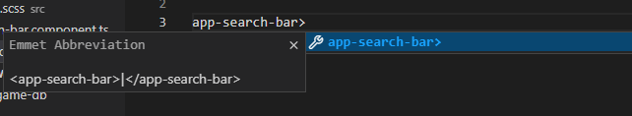
* Parent select &
  + The parent selector, &, is a special selector invented by Sass that’s used in nested selectors to refer to the outer selector. It makes it possible to re-use the outer selector in more complex ways, like adding a pseudo-class or adding a selector before the parent.
  + <https://sass-lang.com/documentation/style-rules/parent-selector>
* 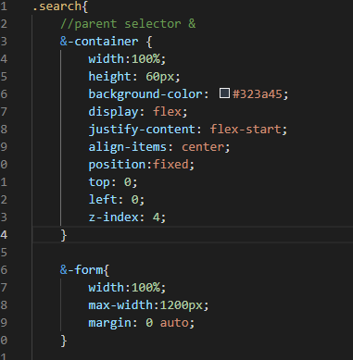 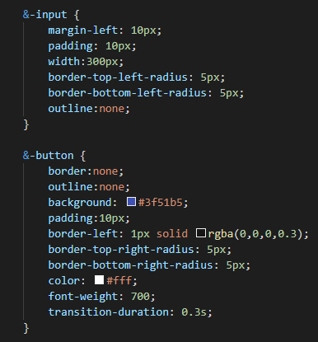
* 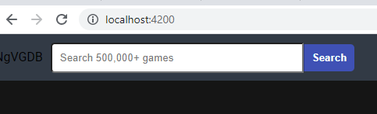
  + Two html tags: input with placeholder and button
    - Input is style to have rounded corners at top left and bottom left
    - Search button is styled to have rounded corners at the top right and bottom right
* Added hover effects so the search button changes color scheme and the mouse becomes a cursor when hovering over the search button
* 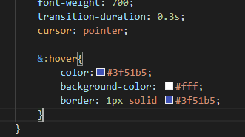
* Updating the style for the logo
* 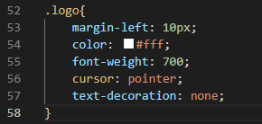 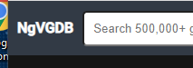

## OnSubmit Form

* Setting up the onSubmit for the search button
  + Newer version of angular results in the same error displayed in console but the search bar component does not appear on the website which is shown on the URL
* 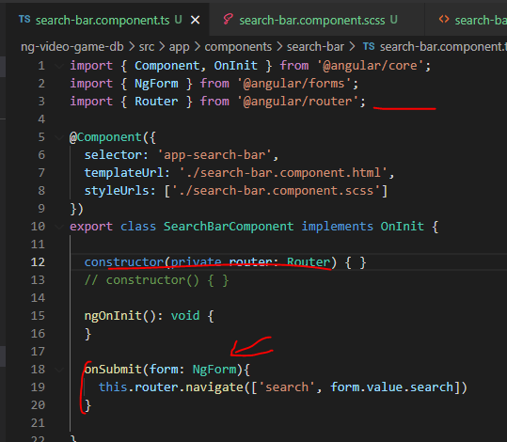
* 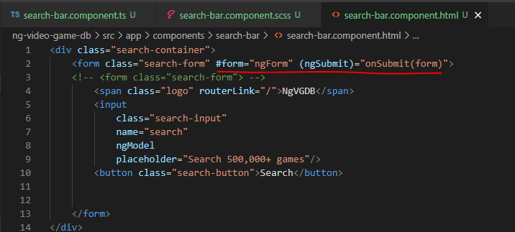
* 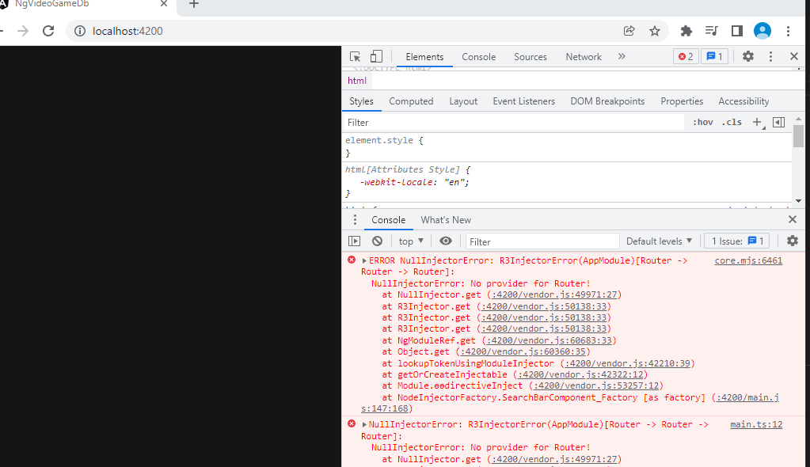
* Correct routing error
* 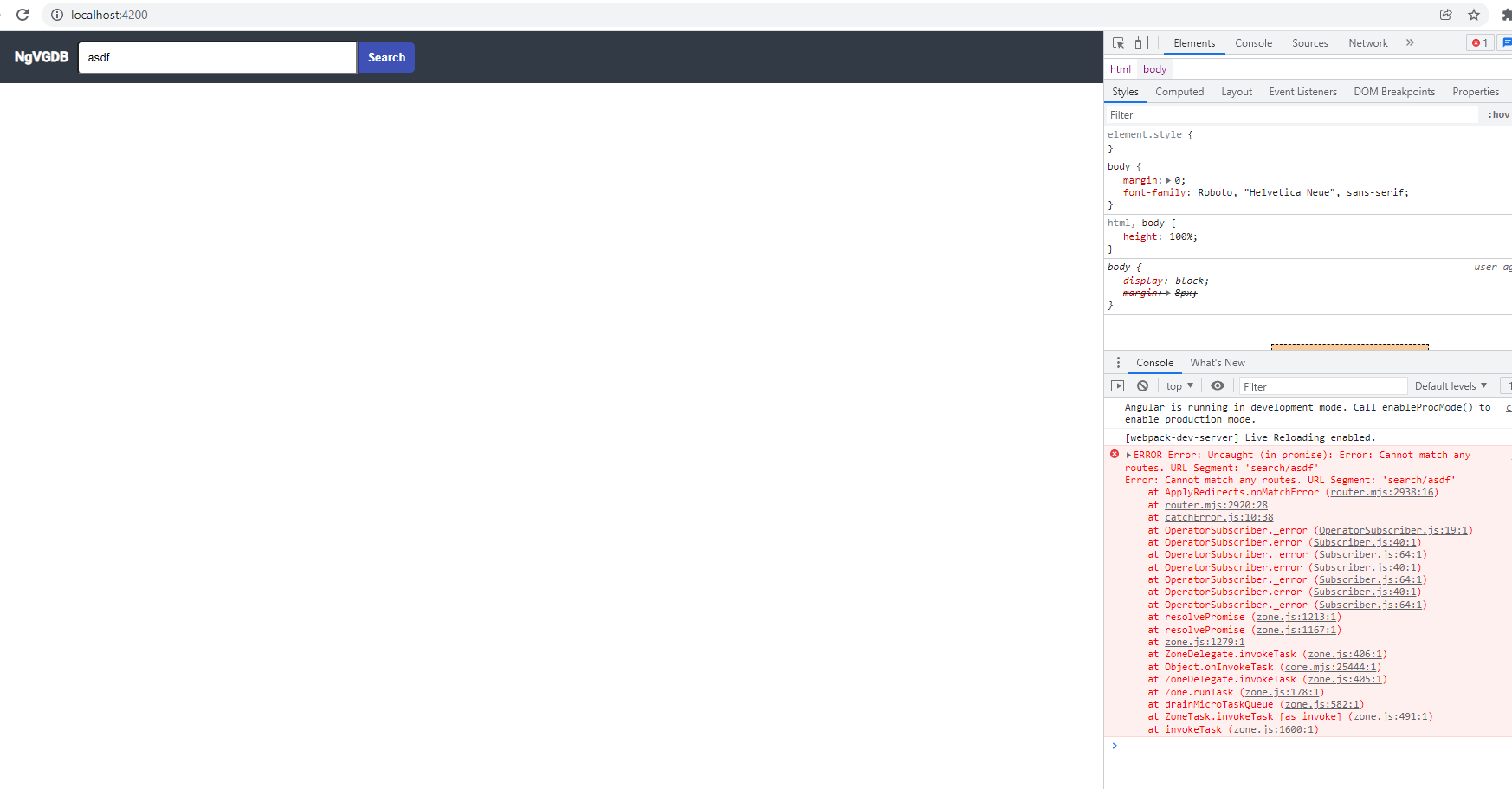
* 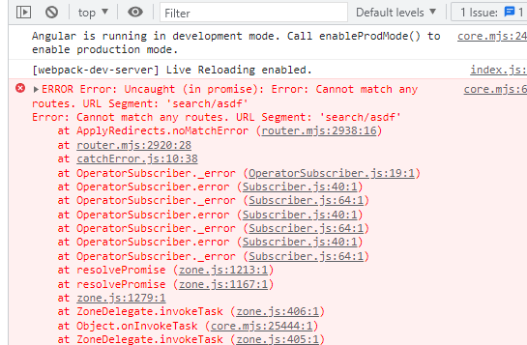

# Home Component

## Adding the component to the app

* 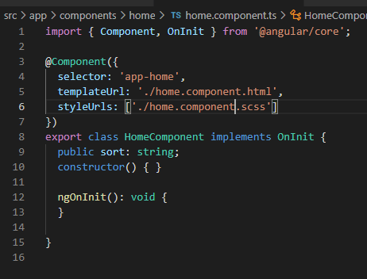
* 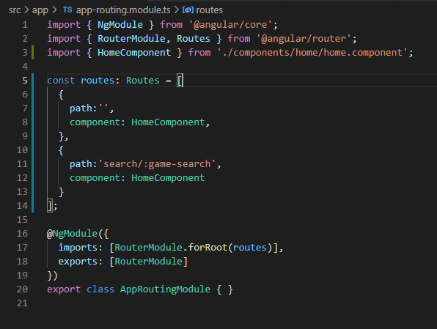
* 
  + Property '...' has no initializer and is not definitely assigned in the constructor
  + <https://stackoverflow.com/questions/49699067/property-has-no-initializer-and-is-not-definitely-assigned-in-the-construc>
  + 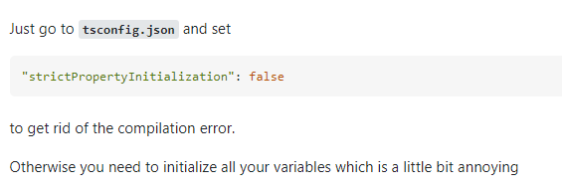
  + "strictPropertyInitialization": false
  + 
  + 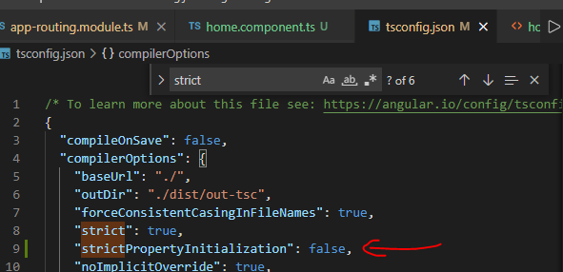

## html

* 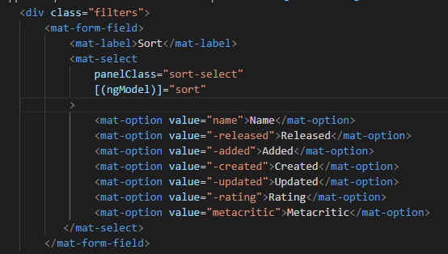

## Styling the html

* 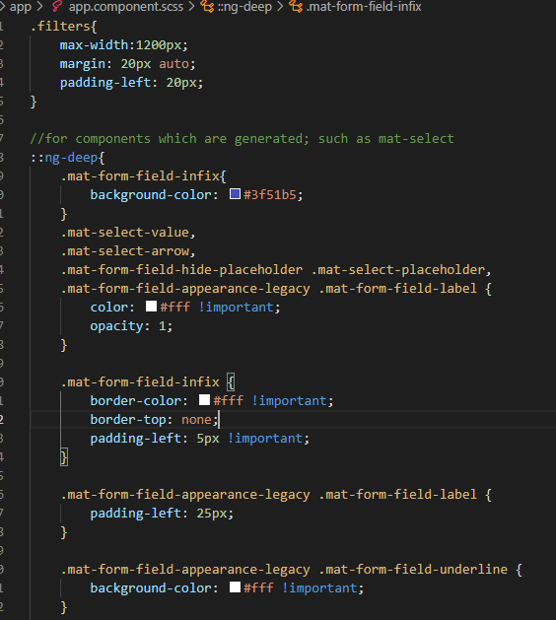

### Games

* 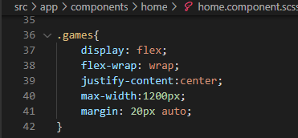

### Game with box shadow

* 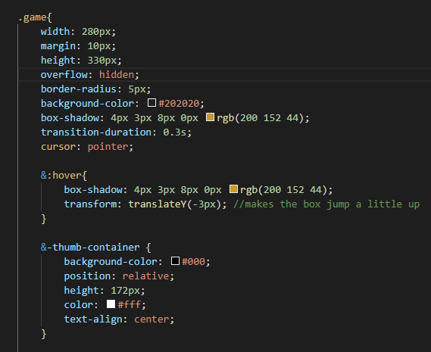
* 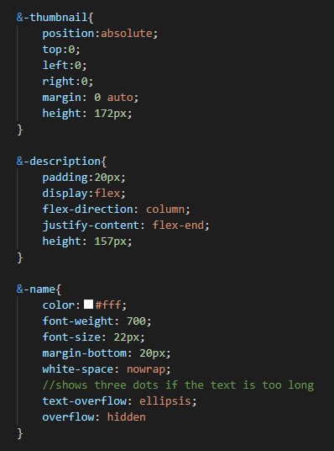
* 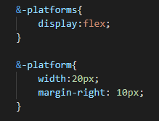

# Creating Http Service

* Create new directory from main dir, cd into it and generate the http service
* 
* 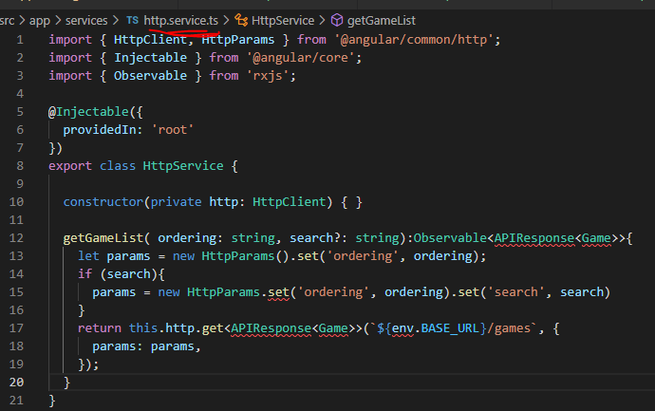
* 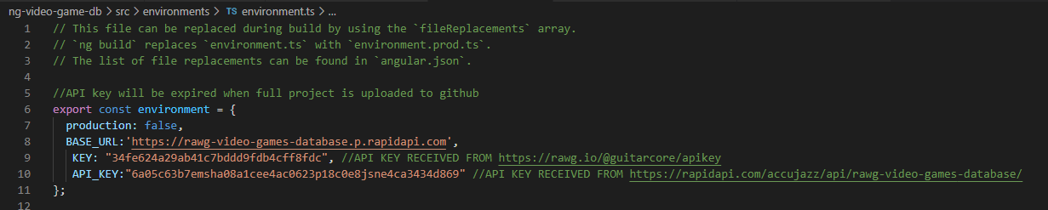
  + The API_key and Key defined for accessing the API

## Models.ts to create interface

* Used to save the information received from the API
* 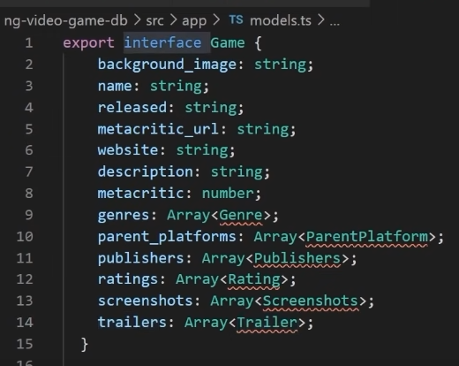
* 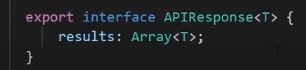
* Now to define all these children interfaces included in the Game interface
* 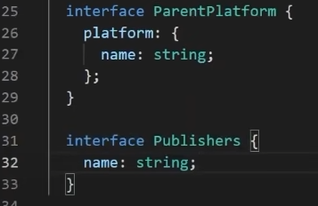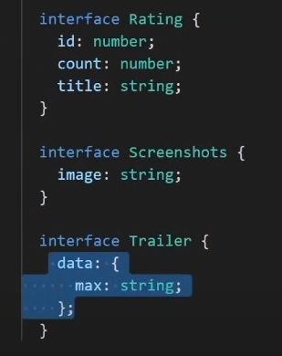

# Http interceptors

* Update the headers at the application level so that each request does not need to be updated with the appropriate headers
* 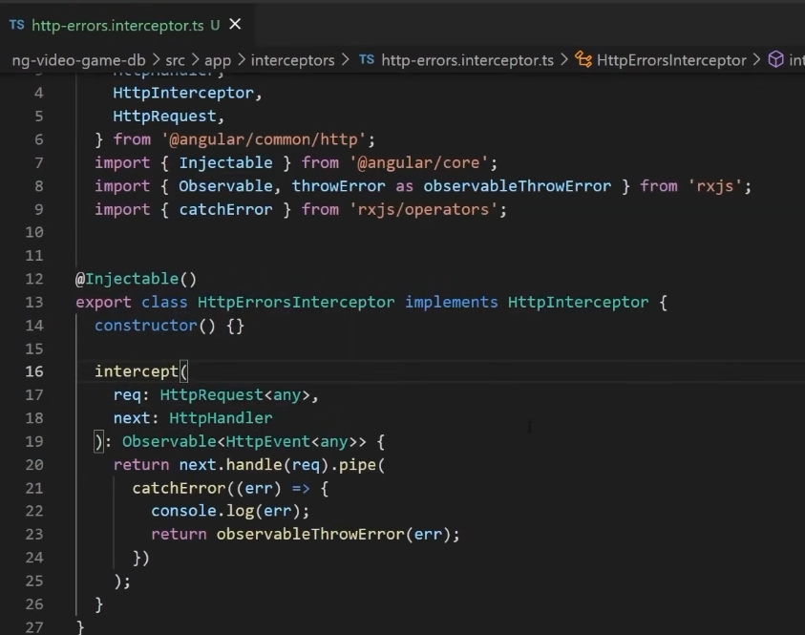
  + Intercepts errors and console logs the error
* 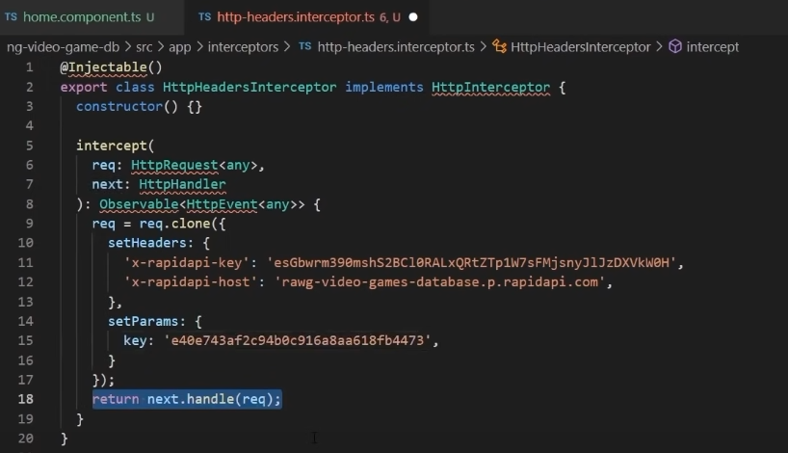
  + Includes the api-key and api-host within the header for any http request
  + Also sets the parameter of the “key”
* Add the interceptors into the providers of app.module.ts
* 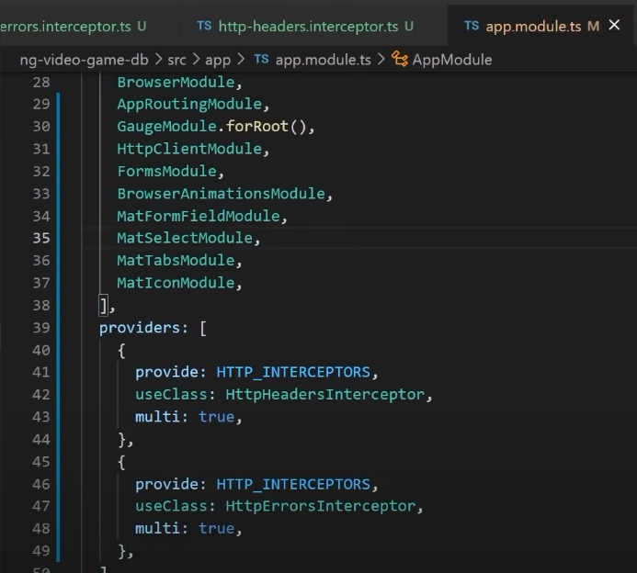

# Implementing the Home Component

* Have the home component display thumbnails for the games returned from the API endpoint
* 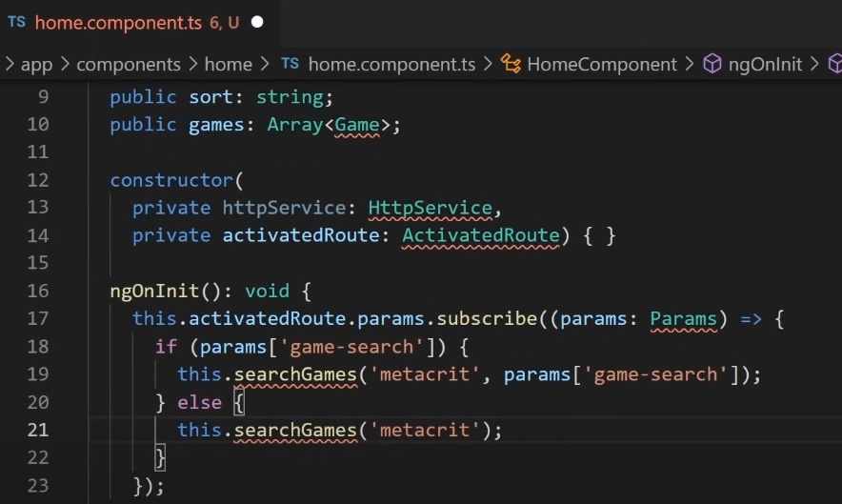
  + Define an array of Game model which we just created
  + HttpService and ActivatedRoute objects are instantiated in the constructor
    - <https://angular.io/api/router/ActivatedRoute#params>
* On initialization, the activatedroute.params is “an observable of the matrix parameters scoped to this route” which is used to used take the parameters defined on the page
  + “metacrit” is the attribute used by this public api to store the rating of the game
  + Params[‘game-search’] is the search query that was entered on the front end
  + The searchGames method will be defined shortly
  + “To execute the observable you have created and begin receiving notifications, you call its subscribe() method, passing an observer. This is a JavaScript object that defines the handlers for the notifications you receive. The subscribe() call returns a Subscription object that has an unsubscribe() method, which you call to stop receiving notifications.”
    - <https://angular.io/guide/observables>
* Search game method
  + 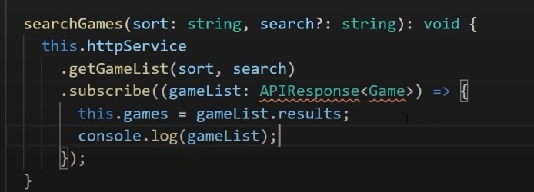
  + Subscribe to the call to the http service’s getGameList method and pass the APIResponse<Game> (Custom interface defined above) which stores the “results” key:value of the json response from the API endpoint into the results attribute of APIResponse object. (can see the results in the console log below)
* Log of the results
  + 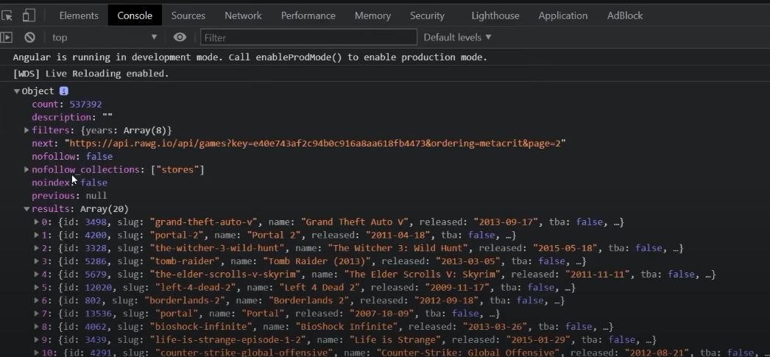
* 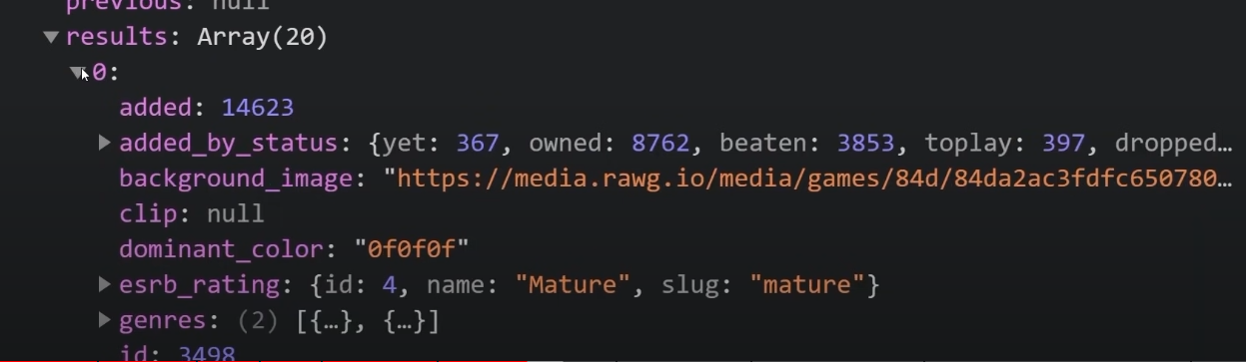

## Inside home.component.html

* 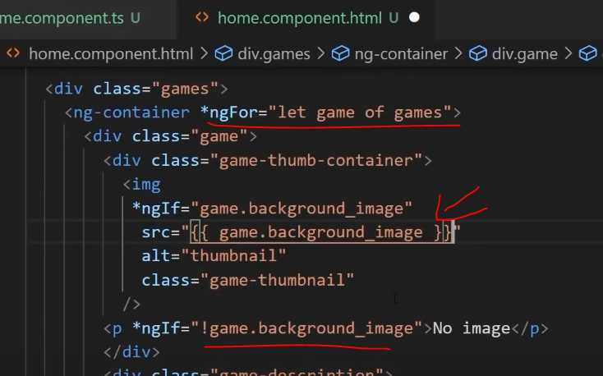
  + For every game of the games attribute, if there is a background image url then use that as the image, if there is no image then only have a p tag with the phrase “No image”
    - As defined in the [home.component.ts](http://home.component.ts), games is an Array<Game>
    - 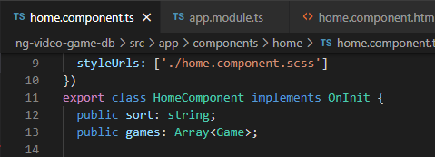
* Also use ngFor to loop through the array to display an icon for each of the game platforms for which the game is available on
  + 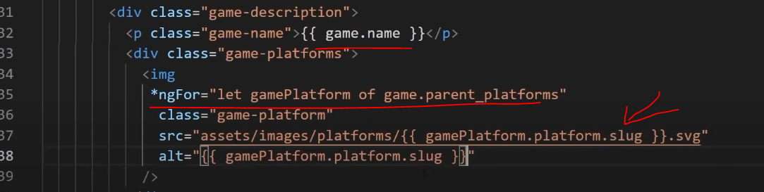
  + Note that the “game.parent_platforms” is just an array of strings
  + The src attribute is the url path to the game icon images which were saved in a particular folder
    - So the for loop checks which game platforms the game is available on and for each of these platforms, adds the respective platform icon into this div class=”game-platforms” which the horizontal row of game icons
    - 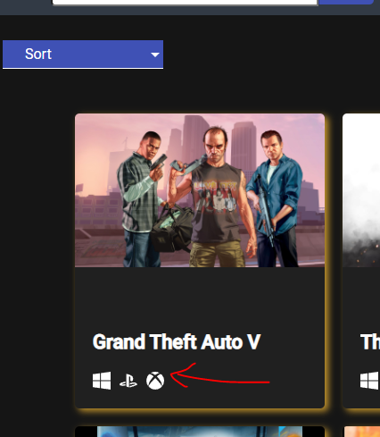
* Now the home component has an array of game icons with their background images, the name of the game and the platforms on which the game is available
  + 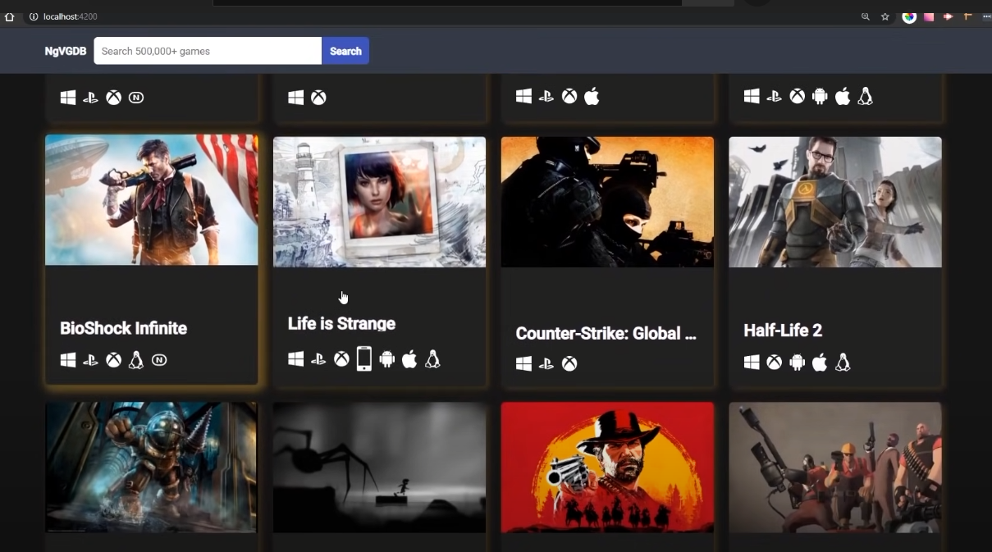

# Implementing the Sort menu

* In [home.component.html](http://home.component.html), update the sort menu to include the selectionchange so that whenever a new sort is selected, the searchGames function is called with the new sort
  + 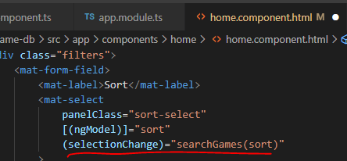
  + Recall that “sort” is also the string variable saved in component.ts
  + 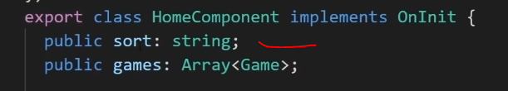
* Looking at the network tab of the chrome devtools when a new sort is selected
  + 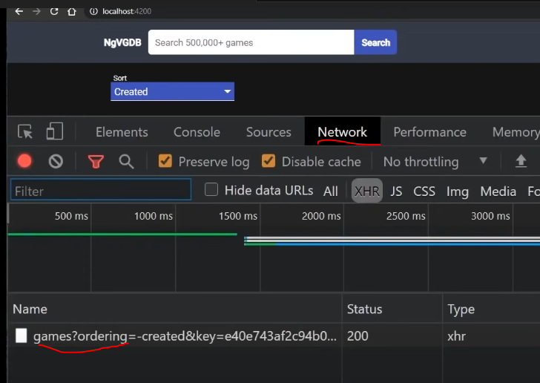
  + Can see the sort being included in the http request because of what is defined in the searchGames method inside home.component.ts

## Creating subscription object to monitor memory leaks

* Create subscription objects
* 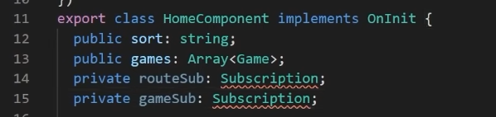
* Assign the subscriptions to these newly declared objects
* 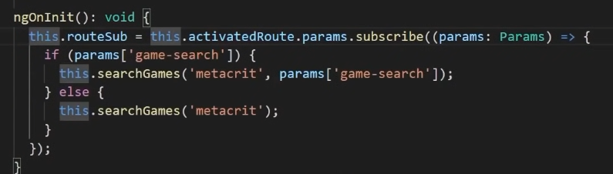
* 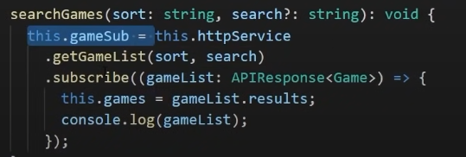
* onDestroy lifecycle hook
* 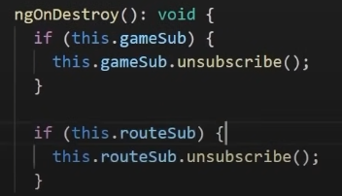
  + If there are any subscriptions then unsubscribe

# Details Component

* Generate component inside components folder
* 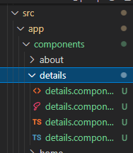 go to components folder and use ng g c details
* Add the new route to the app-routing.module.ts
* <https://angular.io/tutorial/toh-pt5>
  + The colon (:) in the path indicates that :id is a placeholder for a specific id.
* 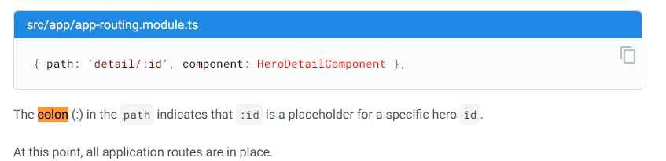
  + Note that it says hero id because the tutorial is for an app which deals with Hero components
* 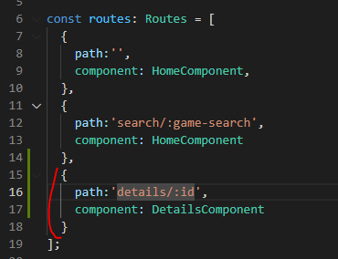

## Click on game thumbnail

* 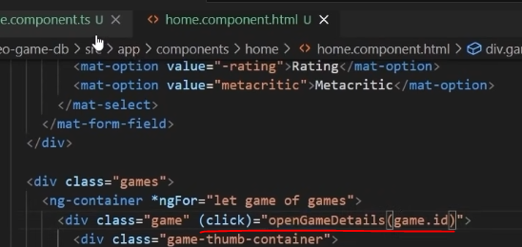
* We want this function to route the user to a page with more details about the game that was clicked on so Router needs to be added to [home.component.ts](http://home.component.ts)
* 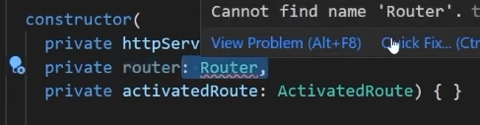
* Create the openGameDetails method
* 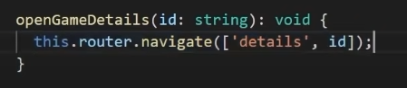
* Router navigates to the details page with id as a parameter

## Updating the html

* 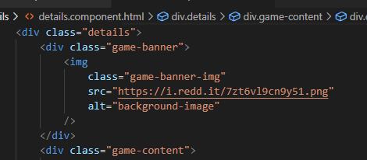 the link for the image is a placeholder I found
* 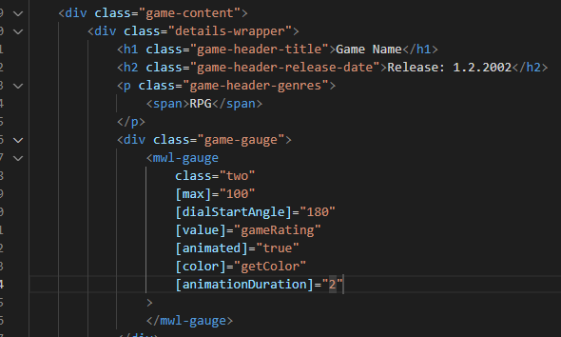
  + Mwl-gauge was a plugin which was installed at the beginning
  + Note that the gameRating is a variable which will be defined now
  + getColor is a function which will also be defined
  + <https://stackoverflow.com/questions/3483391/what-do-square-brackets-in-class-names-mean/3483536#:~:text=7%20Answers&text=The%20square%20brackets%20are%20used,words%2C%20they%20detect%20attribute%20presence>.
  + What do square brackets in class names mean?
    - The square brackets are used as an attribute selector, to select all elements that have a certain attribute value. In other words, they detect attribute presence.
    - 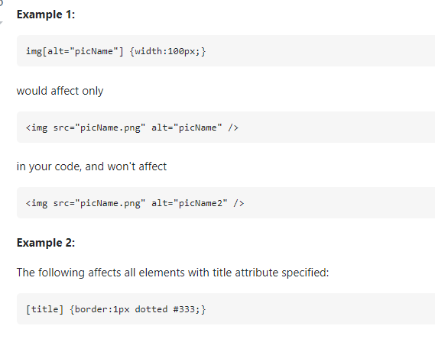 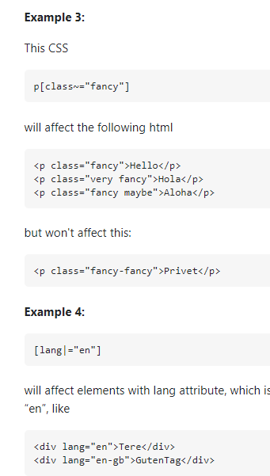
* In Details.component.ts
* Above the constructor, initialize the gameRating variable
* 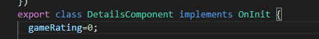
* getColor method
* 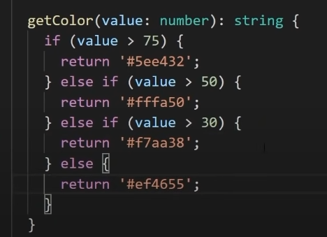
* Going back to the html, after the mwl-gauge
* 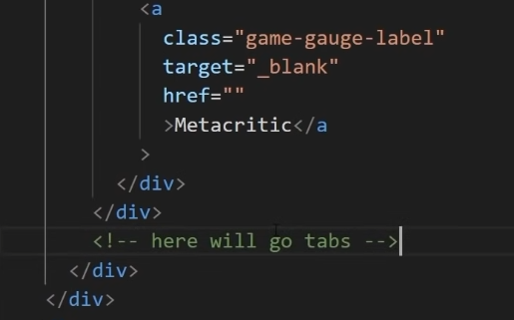
  + Target is blank because we just want to put a link here to where the rating was given from (the metacritic website)
  + Then underneath will be a component with all the tabs

## Styling details.component.scss

* 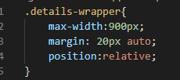
* 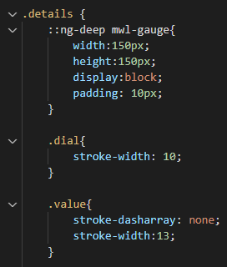 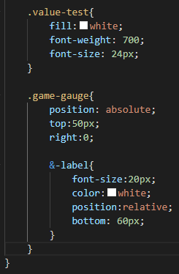
* Ng-deep
  + <https://stackoverflow.com/questions/46786986/how-and-where-to-use-ng-deep>
  + ::ng-deep, >>> and /deep/ disable view encapsulation for specific CSS rules, in other words, it gives you access to DOM elements, which are not in your component's HTML.
* &-label (Parent selector)
  + The parent selector, &, is a special selector invented by Sass that’s used in nested selectors to refer to the outer selector. It makes it possible to re-use the outer selector in more complex ways, like adding a pseudo-class or adding a selector before the parent.
  + <https://sass-lang.com/documentation/style-rules/parent-selector>
  + 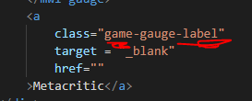
    - So it is “game-gauge” &”-label”
* Css display property
  + <https://www.w3schools.com/cssref/pr_class_display.asp>
  + Block; Displays an element as a block element (like <p>). It starts on a new line, and takes up the whole width
  + inline-block; Displays an element as an inline-level block container. The element itself is formatted as an inline element, but you can apply height and width values
* 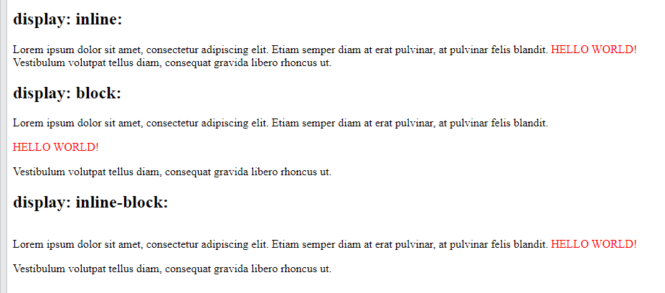
  + 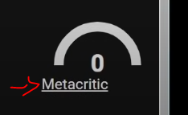
* Modifying the css for the game details
* 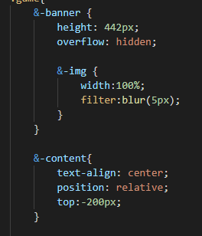 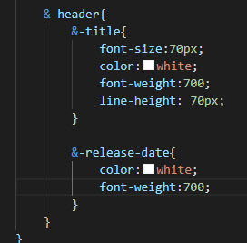

## Autofill the game details component

* 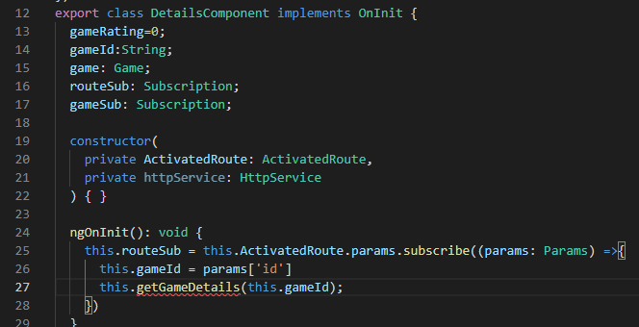
  + Added new variables inside the component above the constructor
  + Injected two dependencies inside the constructor
    - ActivatedRoute for utilizing the API after the connection has been activated
    - httpService to make the http requests to the API
* 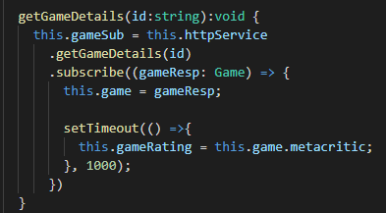
  + Subscribe to the service, get the Game object from the call to the API endpoint
  + Set a timeout before the metacritic score is saved to the game rating variable
    - So that this way, the user gets to see the animation for the gauge fill to match the metacritic score
    - 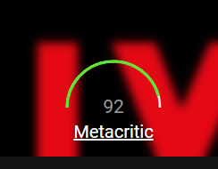
* Create the method inside the httpService
* 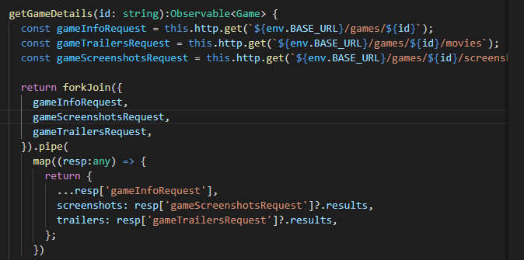
  + Forkjoin
    - <https://www.learnrxjs.io/learn-rxjs/operators/combination/forkjoin>
    - This operator is best used when you have a group of observables and only care about the final emitted value of each. One common use case for this is if you wish to issue multiple requests on page load (or some other event) and only want to take action when a response has been received for all.
  + GameInfoRequest has obtained all the information on the game but it looks like the movies and screenshots endpoints are to fill in the screenshots and trailers data members of the Game model
    - 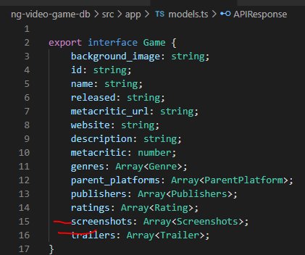 
    - So the metacritic score is already being loaded into the webpage at this point

## Update details.component.html

* Update details.component.html to extract the appropriate data for each game
* 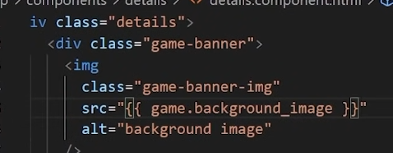
* 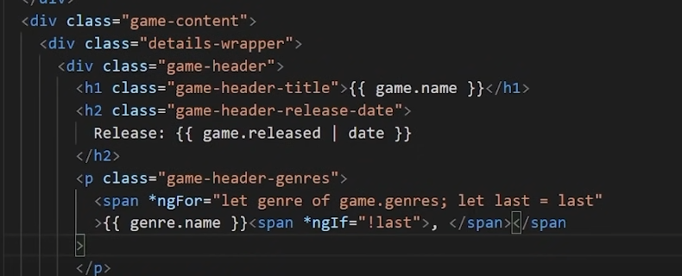
  + Notice the pipe “|” used to formatted the release date as a date
  + Span are inline elements so the ngFor creates one single line with a span for each genre.name
  + The “last” variable is used to check whether or not to still include a comma behind the genre name. It seems that each genre in the genres list is considered before the “last” variable is assigned “last” so the last span has a ngIf condition of false.
  + 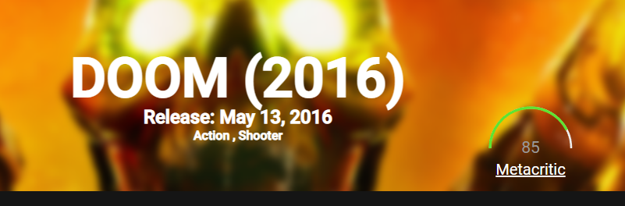
* 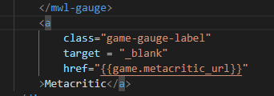
  + Finally update the href to get the metacritic url
    - Note that some urls do not work
    - GTA V does have a valid url
    - Target=”_blank” opens up the url in a new tab on the internet browser
* 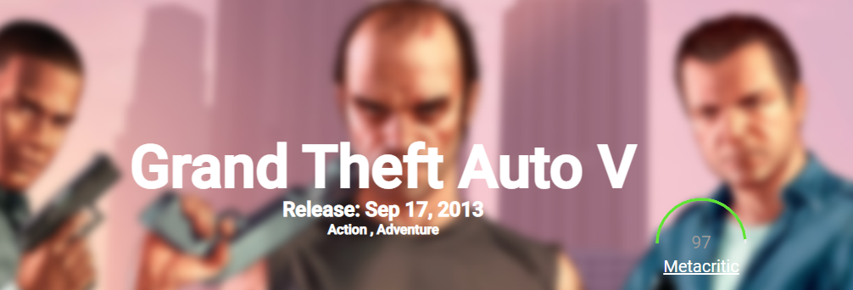 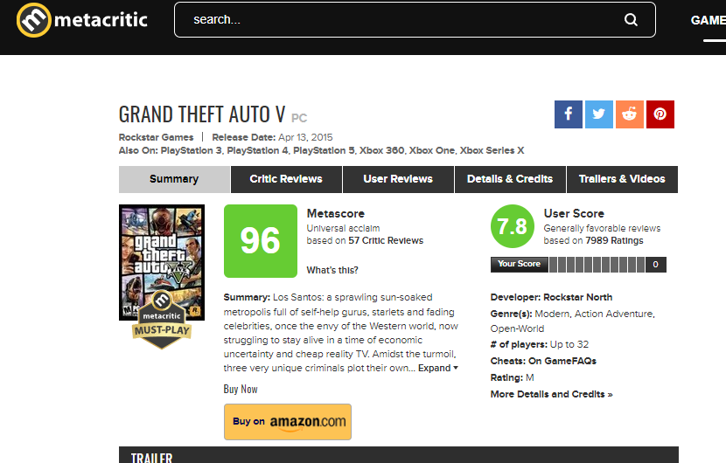
* Again clean up subscriptions within the DetailsComponent.ts after use
* 
* 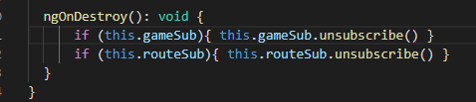

# Game-tabs component

* Cd to components and ng g c game-tabs
* 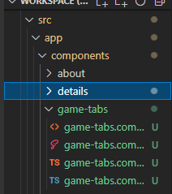
* Using mat-tab for the tabs
* About tab
* 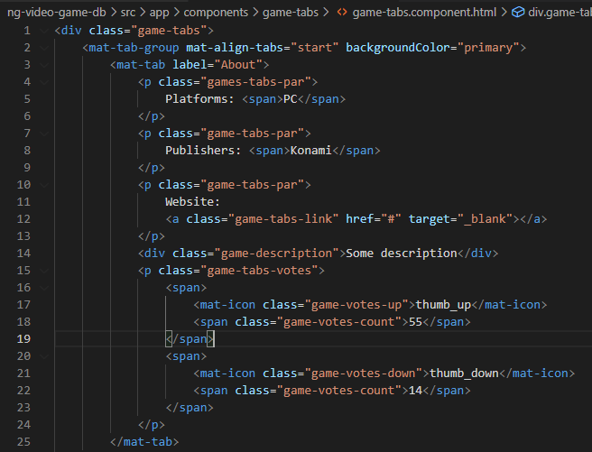
* Screenshots and video trailer tabs
* 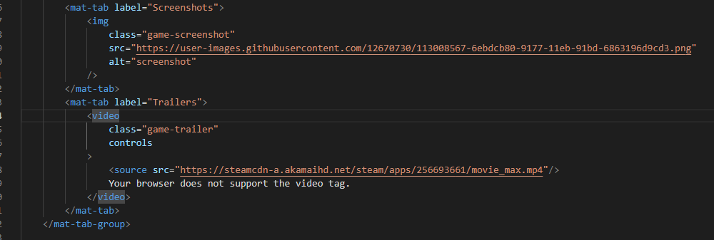

## Styling the tabs

* Styling the tabs themselves
* 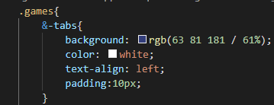
* 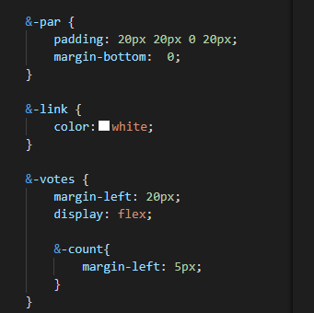 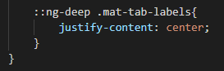
  + 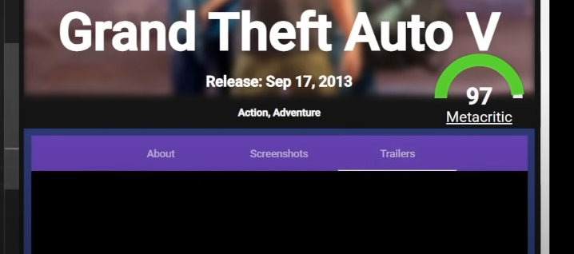
  + Centered the mat-labels along the tabs header
* Note that I had to add padding to the h1, h2 and p tag used in the details (ie modified in details.component.scss) so that the tabs navbar would not be overlapping with the metacritic link
* Before
  + 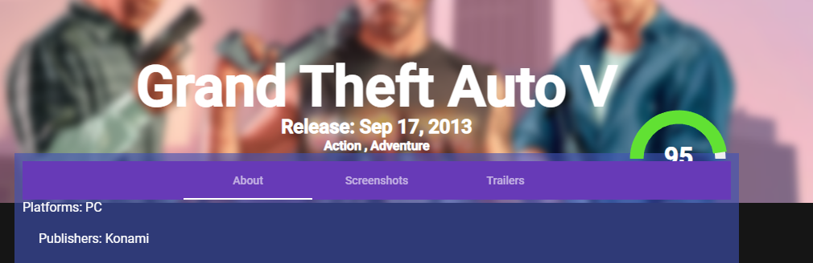
* After
  + 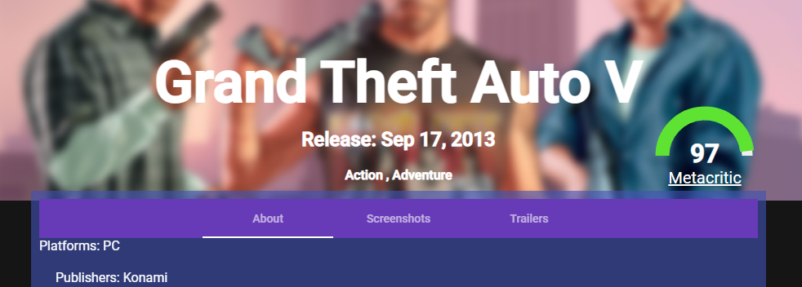
  + 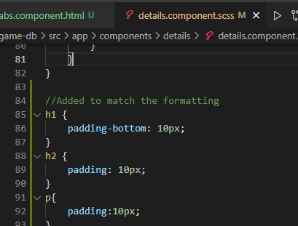
* Adjusted the votes section
* 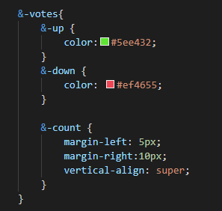
  + Vertical align: Aligns the baseline of the element with the superscript-baseline of its parent.
  + <https://developer.mozilla.org/en-US/docs/Web/CSS/vertical-align>
* 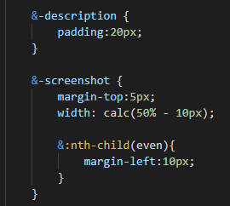
  + Description had padding added so that there would be some space before the votes section
  + 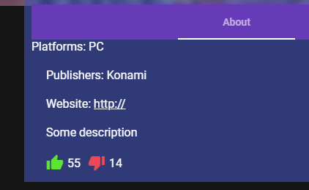
* 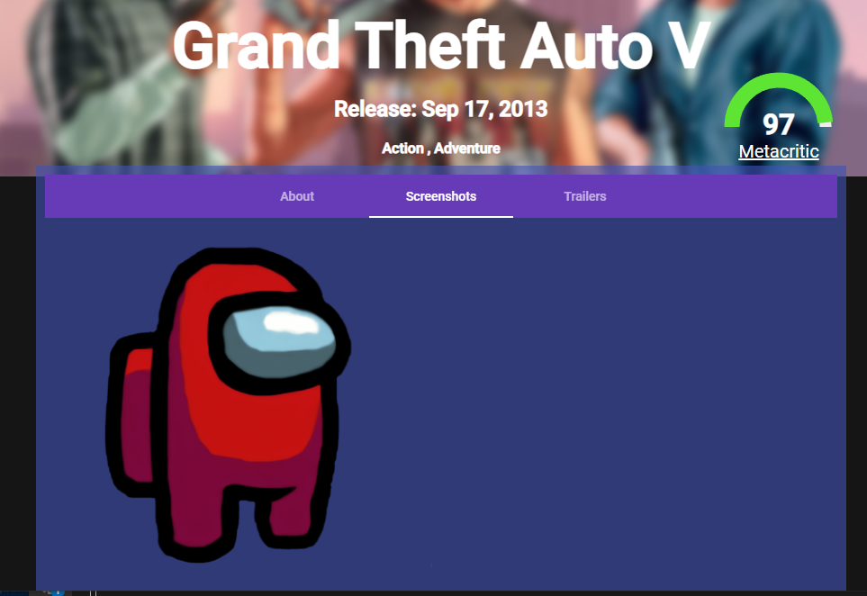
  + Screenshots would now only take up ~50% of the width of the page so that two screenshots can be included on every row
  + N-th child selector
    - For every 2nd element (even), there is a left margin of 10px
    - So this way, the full width is (50%-10px) + 10px + (50%-10px) when you look at the width of this row of 2 images
    - <https://www.w3schools.com/cssref/sel_nth-child.asp>
* 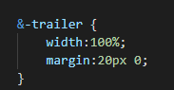

## Dynamically load in the data (Parent to Child component)s

* This component will take in an input of an object of type Game (which is our model which already holds all the information we want to display)
* 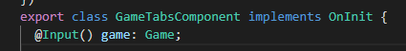
  + Add in this Input annotation inside the component.ts file
* Going back to the parent component html, we can pass in the input
  + 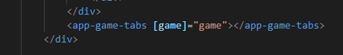
  + This is how the parent can pass data to a child component
* If the length of the parent_platforms array is not zero then proceed to list out all the parent platforms
* 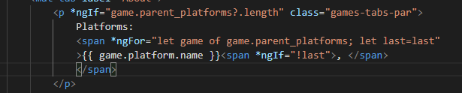
  + ? operator in angular is called the optional chaining operator
  + 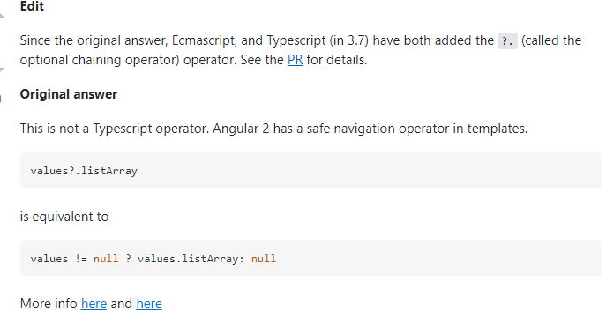
  + <https://stackoverflow.com/questions/45922715/what-is-the-meaning-of-question-mark-in-expressions-in-angular-2/45922773>
  + again the ngFor has a let last=last which makes sure the comma inside the span tag with the ngIf statement does not appear for the last element of the parent_platforms array
* same thing for publishers
* 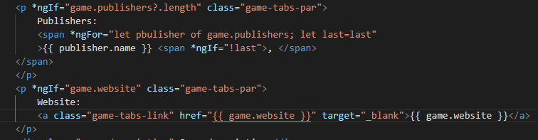
* For the game description, the innerHTML attribute is used to just take the raw text from the input game underneath its description variable and put that inside this div
* 
* 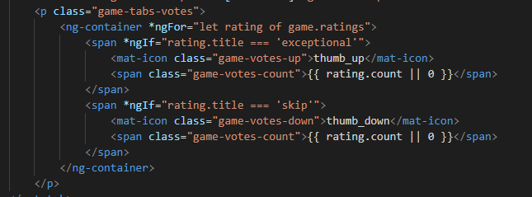
  + For the each rating of the game’s ratings, if the title was exception then show the thumbs up and the number of votes for the game as exceptional or display zero if there is none to count
  + Ng-container
    - <https://angular.io/api/core/ng-container>
    - The <ng-container> allows us to use structural directives without any extra element, making sure that the only DOM changes being applied are those dictated by the directives themselves.
    - This not only increases performance (even so slightly) since the browser ends up rendering less elements but can also be a valuable asset in having cleaner DOMs and styles alike.
    - It can for example enable us to use structural directives without breaking styling dependent on a precise DOM structure (as for example the ones we get when using flex containers, margins, the child combinator selector, etc...).
* 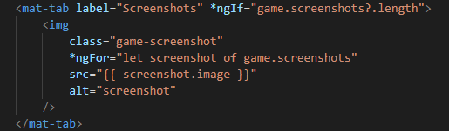
  + Interesting that the for ngFor loop loops through each of the screenshot images saved in “screenshots” which is defined inside the img tag but there are multiple img tags created as a result
    - Other examples of ngFor show the inner child tags as what is repeated during this loop
* 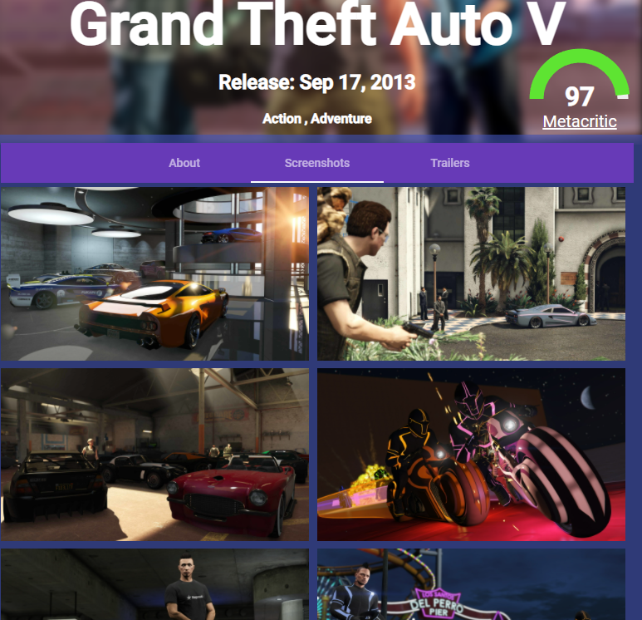 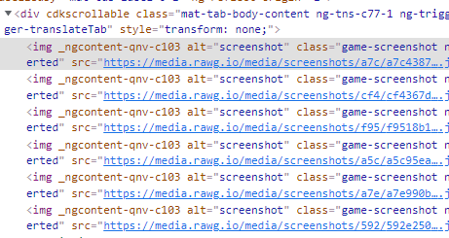
* The source of the video trailer is stored inside trailer.data (ie the url link), the “.max” is to specify the highest resolution
* 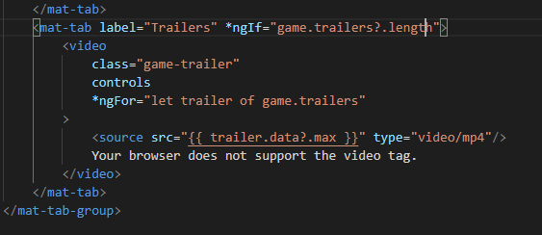
* a